**How to create a personal access token (PATs) in Azure DevOps?**

Personal Access Token (PATs) can be used for password less authentication for Agent pool creations, git or REST API in Azure DevOps.

PATs are easy to create when you need them and easy to revoke when you don’t.

**Prerequisites:**

Step 1: Login to your Azure DevOps account using below link

<https://dev.azure.com/your_organization_name>

Step 2: Select user setting icon in the top right corner and click “Personal access tokens”.

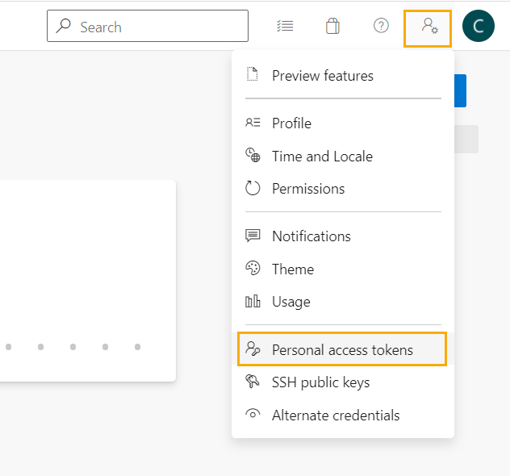

Step 3: Click on “New Token” to generate a new personal access token.

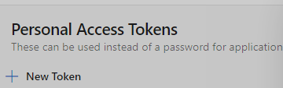

Step 4: Provide a name, organization, expiration date and scope for your personal access token and click “Create”.

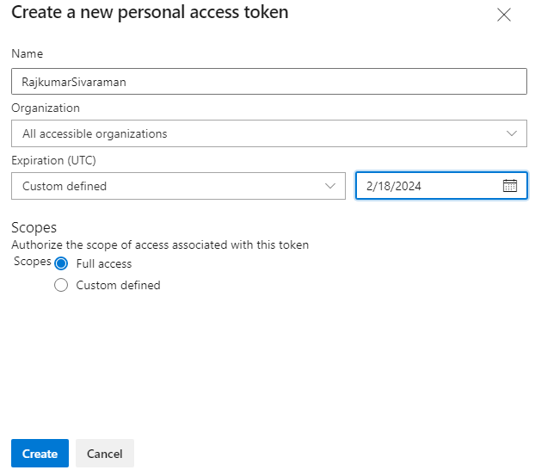

Step 5: Copy and store the personal access token into a safe place and close the window.

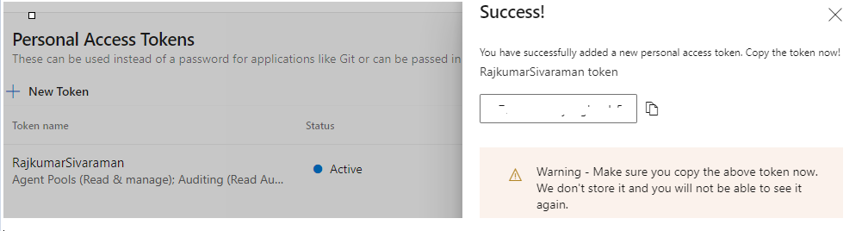

**Note: Always store your PATs in a secure place as we cannot get it from any logs afterwards.**

Our Personal Access Token (PATs) has been created successfully. You can revoke or regenerate this PATs anytime from this same location.

